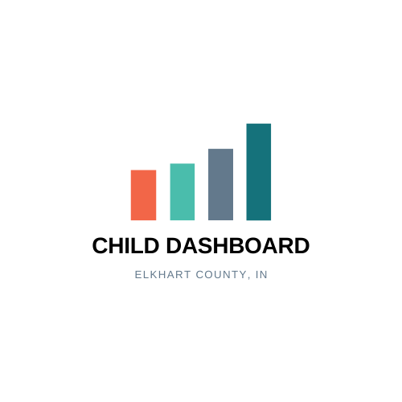
Frequently asked questions

- What is the Elkhart County Child Dashboard?
- A collaborative community dashboard that tracks publicly available and internal local datapoints that can serve as indicators for child wellbeing and safety in Elkhart County.
- How is the data organized in the dashboard, and why?
- The child dashboard looks at indicators for child wellbeing through two lenses: risk factors and protective factors.
- Each of these lenses has its own dashboard, one focused on risk indicators and one focused on protective indicators.
- Each of these dashboards have 4 columns that represent a different step on the pathway from very upstream warning signs and social determinants all the way through to the direct outcomes that we are trying to avoid or encourage.
- The goal of organizing data indicators this way is to allow the dashboard user to visualize a progressive logical relationship between groups of data points, both negative and positive. When we see a whole group of indicators trending in the same way it can send a strong message about what is happening on the ground.
- We hope that this logical progression allows dashboard users to see opportunities for interventions and collective community action at each step, in order to avoid further escalation of problem trends and/or to encourage increased protective activities.
- What is a dashboard indicator?
- a data point that provides quantitative information that can tell us something about child wellbeing and safety in the county. No single data point is perfect or tells the full story, but together looking at datapoint from across so many organizations and sectors we hope to be able to see the most important trends in child wellbeing and safety in our county and be able to respond nimbly and proactively as a community to make a difference.
- Who hosts and administers the dashboard?
- The SOURCE, Elkhart County’s System of Care hosts and administers the Child Dashboard. The SOURCE is Elkhart County’s public mental health system of care, a collaborative network made up of over 50 organizations who service children and youth in Elkhart County. The SOURCE is housed at Oaklawn.
- Why a dashboard?
- The dashboard was created to allow Elkhart County decision makers and leaders to have regular access to important child wellbeing and safety indicator data, both positive and negative. This allows leaders to see beyond their organizational and sector data silos and see early trends and opportunities for action. This dashboard can allow leaders to better understand real-time priority needs in the county, communicate effectively about the role their organization can play, more strategically seek funds and fill gaps, and drive strategic change within their own organizations and across the community.

- Who is the intended dashboard audience?
- For the first-year pilot of the dashboard, the intended audience is the leaders of collaborating partner organizations, which include social services, government, health and education and industry representatives.
- How often will the dashboard get updated?
  - the child dashboard will officially launch in September 2021 and will be updated with available data every quarter. These quarterly updates will be sent to collaborating partners and discussed in quarterly in person collaboration meetings.
- Who can I contact if I have ideas for additions, changes or stories connected to the dashboard data?
- The SOURCE is managing the dashboard and can be reached at thesource@oaklawn.org.

- How does the dashboard stoplight/color coding system work?
  - The dashboard uses a 3-color stoplight system to give dashboard viewers a sense of whether the indicator is trending in a desirable or undesirable direction.
    - Green- the trend is moving in a desirable/good direction compared to the prior period.
    - Grey- neutral, no significant change or non-categorizable
    - Red- trend is moving in an undesirable/bad direction compared to the prior period.
10. What is the dashboard development timeline and what changes to the dashboard can I expect in the coming years?
    - June 2020- beginning work on dashboard, stakeholder buy-in, first draft dashboard created.
    - December 2020- technical team assembled (enFocus, IU)
    - March 2021- First dashboard prototype presented to Elkhart Community, 16 collaborating partners participating.
    - June 2021-Second prototype with full data reviewed with focus stakeholder group.
    - September 2021-First version dashboard released to collaborating partners.
    - September 2022- Second Version dashboard released, possibly with demographic data added to dashboard indicators where appropriate.
    - September 2023- dashboard released to wider community audience
11. Who provides the dashboard indicators?
- You will see two types of indicators on the dashboard, publicly available data and internal local partner data that comes from an Elkhart County organization who is willing to share a specific data point regularly with the dashboard.
- Partners providing local data are selected with the following criteria in mind:
  - Are in some way representative of the sector- i.e., YWCA is well placed to share a data point connected to incidences of domestic violence and care seeking for domestic violence.
  - Have a good reputation/are respected by peer and partner organizations.
  - Have given input in an iterative process to determine what important data they might provide that would meet the following indicator criteria:
    - Can this indicator inform and drive action?
    - Is the indicator source a trusted sharer/representative of this data?
    - Does the data show significant enough movement on a quarterly basis to show meaningful trends?
    - What effort is required to obtain the data compared to the value of the indicator to the community?

